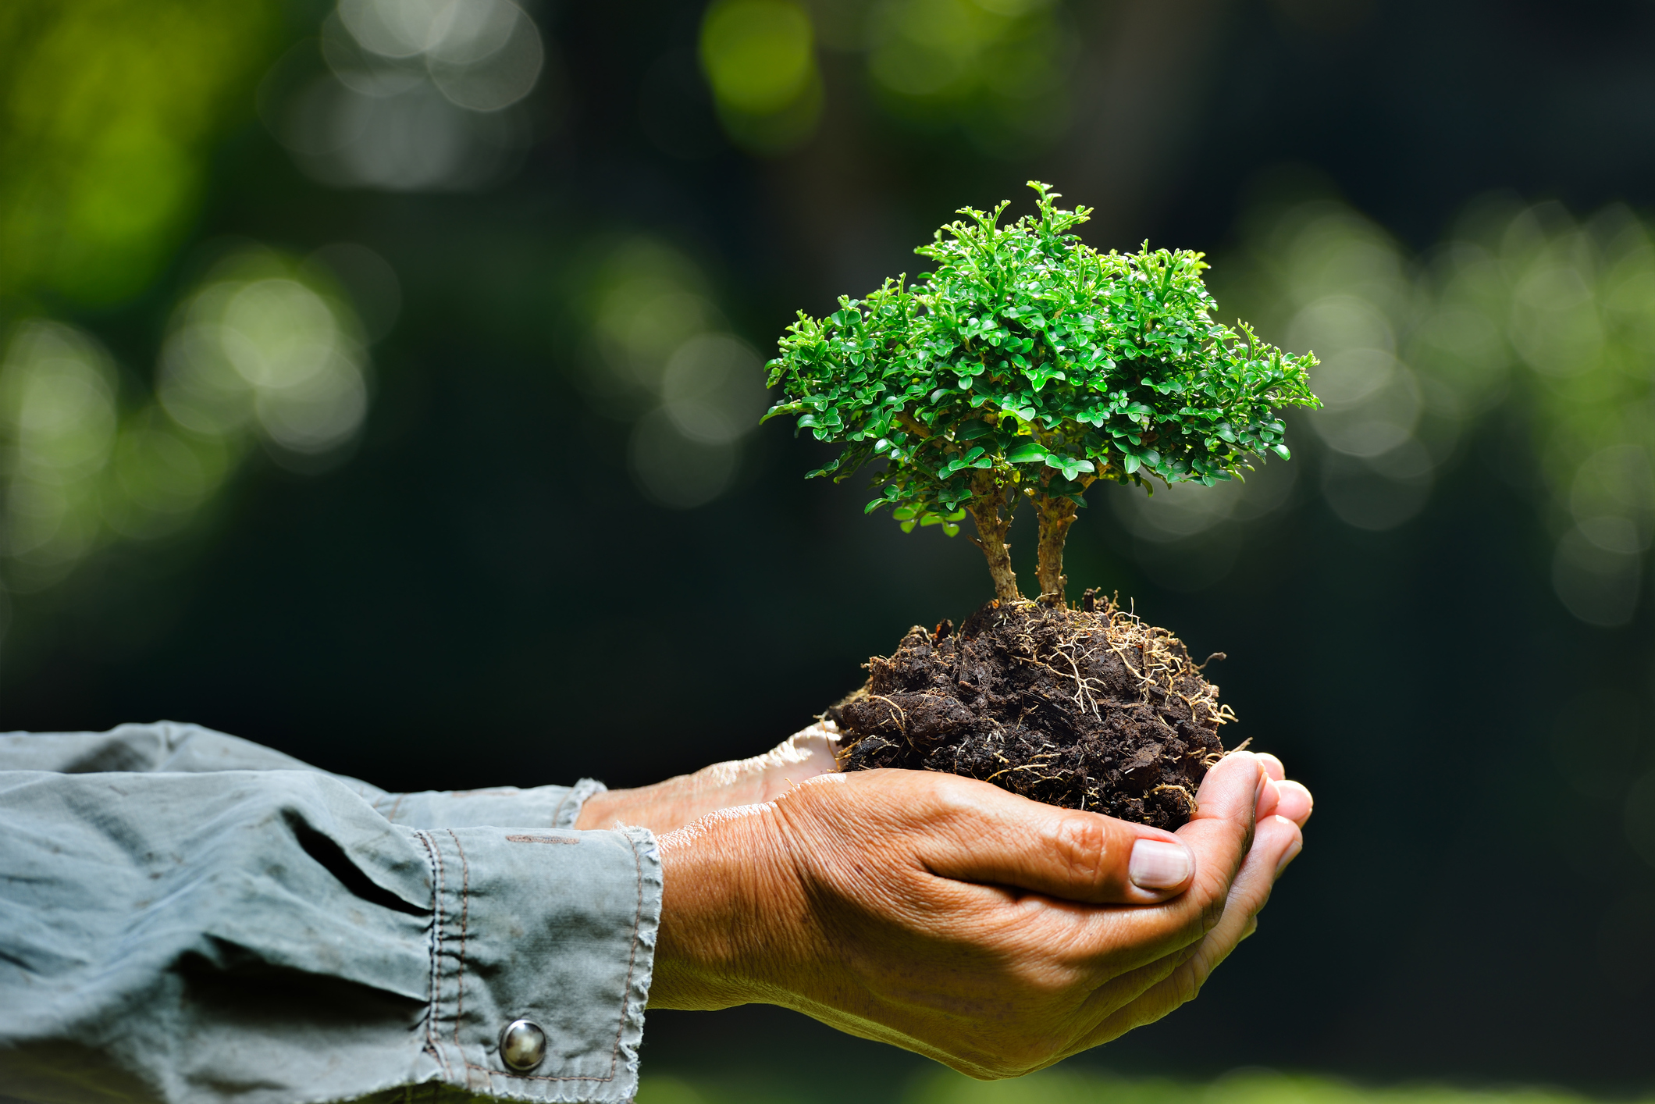

**Haya Alnuaimi**

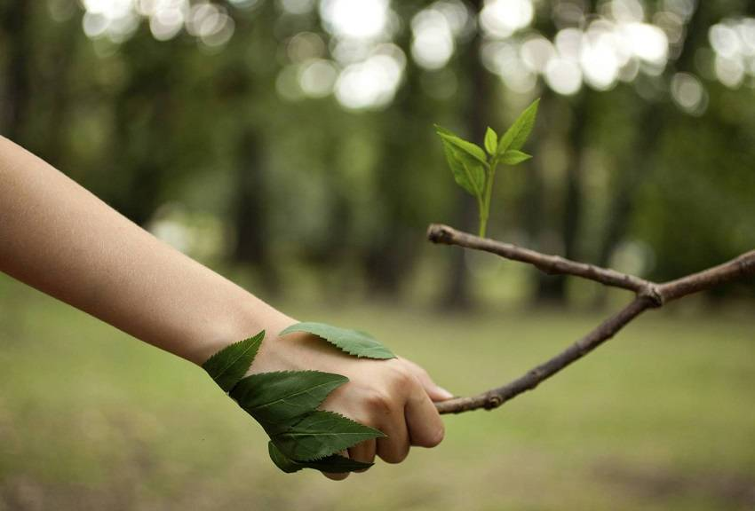

**The people who cared…**

**The people who cared…**

Haya Alnuaimi

I saw trees being cut

I heard animals were being shot

I looked up the sky but it was so dark

I smelled the factories they smelled like rot

I looked at the people they were trying to hunt

But, then I saw a tree that grew a lot

It was my only hope; it felt like before, I was so lost

That tree was you Jane and Tara

I knew you came to save the world

You saw what was behind it you were both bold

You didn’t’ fear what was happening around you but you noticed it was cold

You came here to see who cared

You came to the right place because we listened, we heard

Mother nature crying from pain

Waiting for something, waiting for rain

I stand here to tell you we must gain

Gain the respect from nature and animals again

You taught us to stay hand in hand

Because, we are heading to the right end

Thank you for trying and for the message you wanted to send

We will help Mother Nature because; it’s out precious friend

We will try out best to hold the inspiration

Because of you Jane and Tara we will save our nature for the future of an upcoming generation.